**Implementation of Counter using Timer**

**Lab #09**



Spring 2022

CSE-307L Microprocessor Based system Design

Submitted by: **Ashfaq Ahmad**

Registration No: **19PWCSE1795**

Class Section: **B**

“On my honor, as student of University of Engineering and Technology, I have neither given nor received unauthorized assistance on this academic work.”

Student Signature: ______________

Submitted to:

**Dr: Aber Irfan sab**

**August** 1, 2022

**Department of Computer Systems Engineering**

**University of Engineering and Technology, Peshawar**

**Task 01:** Design a counter without using Timers of microcontroller.

**Source Code:**

#include <reg51.h>

#include <stdio.h>

#define seven_seg P2

sbit Unit=P3^0;

sbit Ten=P3^1;

unsigned int count=0;

int u=0;

int t=0;

int x;

unsigned char ch[]={0x40,0x79,0x24,0x30,0x19,0x12,0x02,0x78,0x00,0x10};

//{0,1,2,3,4,5,6,7,8,9} seven segemnt code in hex for active low (0).

void main(void)

 {

   while (1)

   {

      Unit=1;Ten=0;   //we can't use both seven segment at a time.

      u=count%10;

      t=count/10;

      seven_seg=ch[u];

      for(x=0; x<20000; x++);

      Unit=0; Ten=1;

      seven_seg=ch[t];

      for(x=0; x<20000; x++);

       count++;

      if(count==100)

      count=0;

   }

 }

**Output:**

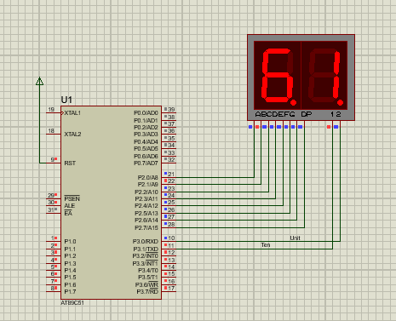

**Task02:** Design a Counter Using Timer as a Counter .

**Source Code:**

#include <reg51.h>

#include <stdio.h>

#define output P2

sbit unit=P3^0;

sbit ten=P3^1;

sbit button=P3^4;       //timer zero

int x;

int U=0,T=0;

unsigned char out[]={ 0x40,0x79,0x24,0x30,0x19,0x12,0x02,0x78,0x00,0x10};

void init_counter()   //iniitalize counter

{

   TMOD=0x06;    //timer 0, mode 2 , 8-bits register..  we can also use 0x05  timer 0, mode 1 , 16-bits register. the rest part of the code will be same.

   TL0=0x00;      //start from 0. it will be incrementing by pressing button.

}

void start_counter()   //start counter

{

   TR0=1;

}

void main(void)

 {

   int value=0;

    button=1;       //configure as input.

    init_counter() ;

    start_counter();

   while (1)

   {

      unit=1; ten=0;

      value=TL0;

      U=value%10;

      T=value/10;

      output=out[U];

      for(x=0; x<10000; x++);     //display unit part for some delay.

      unit=0; ten=1;

      output=out[T];

      for(x=0; x<10000; x++);  //display ten part for some delay.

      if(value==100)

     TL0=0;

   }

 }

**Output:**

